**Mid Year Review-2019**

**CORPORATE GOALS:**

* Completed all the task assign to me on time.
* Followed the Pershing Standard in all my codes including in both **Mainframe** and Atoms **JAVA.**
* Completed all required compliance and ethics training Programs, disclosures and certification by established due dates and understands the importance of supporting the compliance and ethics training Program.

**1: Analysis and Design**

* I have done details analysis of project, Requirement gathering and what are the business need for the same.
* After all analysis, I do create blue print of changes required for the project and flow of project so that it will help me in coding and testing.
* **E.g**. for Project **963784 - TAG 111 Max Floor Display Size,** I have created flow of screens in OV00 and program changerequired for same

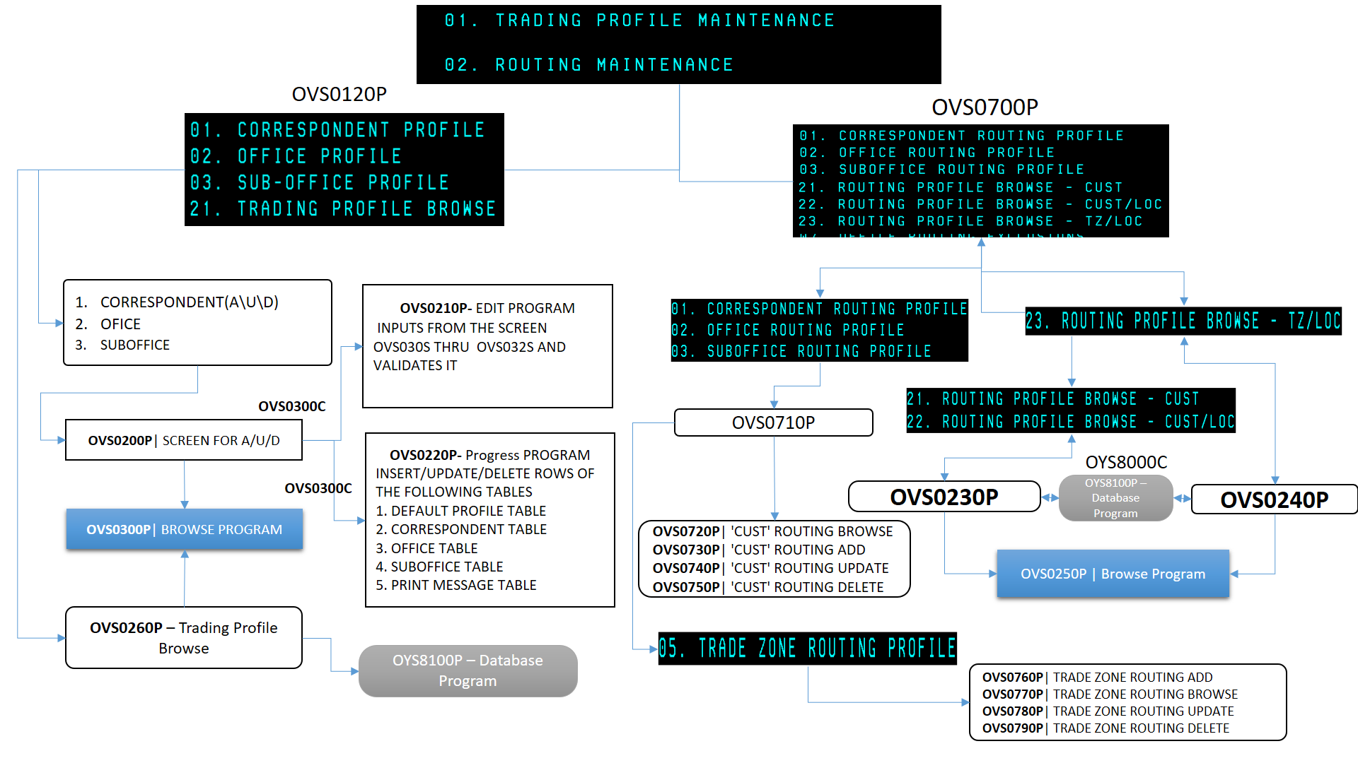

* For Java, we need to do detailed analysis, because there is no debugging tool, if any problem persist.
* Also for project **903035 - IQMS Devices to PII”,** I did requirement gathering, analysis of flow, without which I would never know from which queue we are getting data and where we are sending

**2: Coding and Testing**

* I have completed project 903035 **- IQMS Devices to PII”** with clean code and with all positive and negative testing. This project helped me to improve my knowledge for MQs
* Carried out extensive testing in **INC900003522801: IBD_ID in DataMart atom`s file**’ , in this project we have tested all fields which are sent to DataMart TKG/MSI files. This was completely Batch project
* **Successfully implemented the project 963784 - TAG 111 Max Floor Display Size** individually, for this I did clean and well indented code and done testing for all screens using CICS and COBOL.
* Currently working on project **954160 - New Order Routing Disclosures - For FIRM DESIGNATED ID,** for batch side.
* Currently working on project “**925912 - Consolidated Audit Trail for all exchange listed equities**” in collaboration with TEAM, in this I am taking care of table changes and screen in OV00

* Currently working on project **980306 - Pershing OATS file enhancement - FIX Exchange rate.** in this project we are sending FDID field and exchange rate fields to FIX
* Created Data Dictionary for various copybooks for DA team, took care of table changes implementation in association with DBAs
* Find out solution for **all blockers in SONARQUBE** for **JAVA** code and ready for implementation.

**3: Quality and Process Adherence**

* I do create bulk input order and executions files for every DR process and monitor the process for both JAVA and Mainframe.
* For JAVA, code quality is so neat and clean so that we have very few blockers that is all because of IBM generated code, and we are ready with changes
* Carried out extensive testing in Dev Region before promoting to higher regions.
* Proper documentation of all project, incidences and ADHOC jobs

**4: Issue Resolution**

* Fixed issue in DATA mart files, for BUST orders data were not sending, this come under **INC900003522801: IBD_ID in DataMart atom`s file**’
* Always keeping eye on JAVA Execution process and ready to handle errors and issues.
* Provided support on weekends if there any upgrading related to JAVA.

**GLOBAL COMPETENCIES**

1. Giving KT on Execution process and JAVA process to team and making aware of process
2. Learned more **about CICS, MQs and MAPS** than previous year
3. Self-learning on **java**, Web services like **Angular/HTML/CSS**
4. Self-learning on JENKINS, GIT,SONAR QUBE process for JAVA code
5. Participated in **INNER source initiative-** in that I am currently **working Wealth management project** in completely in my own time on weekends without affecting my current mainframe projects
6. Timely submission of time sheet.

**Extra co-curricular activities:**

1. Arranged H2- Team outing for our team of my own
2. Celebrated women’s day on behalf of my manager with gifts and greeting.